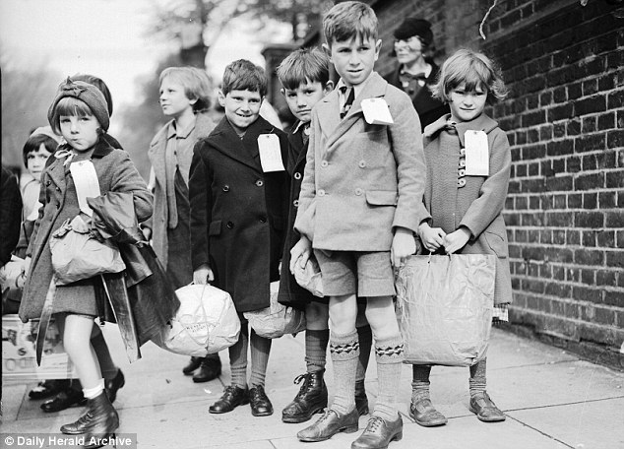
As Artists, we will be researching propaganda posters that were used in the war and creating our own ones.
We will also be decorating props and scenery for our production.
In PSHE we will be looking at our transition to secondary school. We will also be discussing relationships education.
In Geography, we will be studying the countries that were involved in the war, locating key countries on a map as well as identifying human and physical features
As Historians, we will be looking at how WWII started and the important events throughout. We will look at how war affected the local area and how it changed people’s lives.
As MFL experts, we will be developing our conversation skills and working on our fluency in preparation for secondary school. During our transition days and weeks, we will be able to sample secondary school MFL lessons.

As Athletes we will be learning the skills for Tag Rugby.
World War 2
Year 6

In English we will be reading Letters from a Lighthouse Kensukes Kingdom. We will be wiriting Diary Entries, Non chronological reports, biographies and stories.
As Mathematicians we will be consolidating our knowledge of the four calculations. We will further develop our understanding of shape, space and measure as well as looking at problem solving activities. We will also look at creating codes for secret messages like they used in the war.

