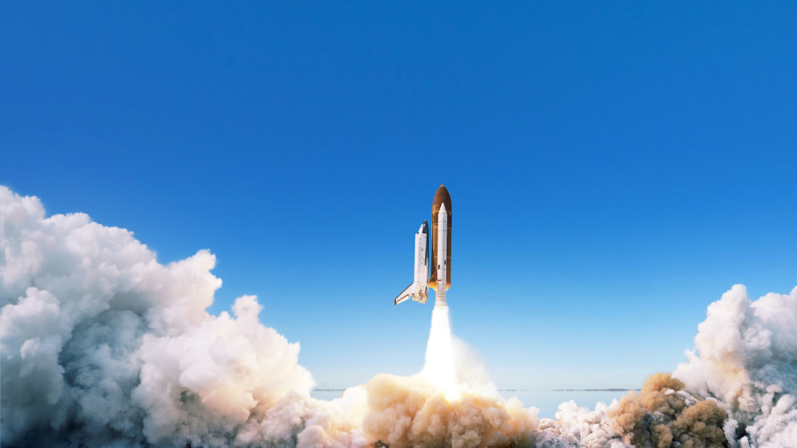
As Geographers we will be identifying the lines of latitude and where desert biomes are located. We will learn about the features of deserts – both human and physical.
We will then learn about the world’s oceans, the benefits of the Great Barrier Reef and consider human impact on our oceans and the consequences of this.
As Historians we will be learning about the Space Race between USA and Russia. We will also be learning about significant people such as Tim Peake, Neil Armstrong, Elon Musk and Mae C Jemison.
As Mathematicians we will continue to improve our understanding of the four rules of number. We will also be continuing to develop our knowledge of Place Value
Multiplication, Division, Shape and Weekly Arithmetic Tests.

In French we will be writing metaphors and making the correct choice of un/une in order to write about planets.
Computing lessons will consist continuing our work on online safety learn about data handling linked to the Mars Rover.
In Religious Education, we are studying spiritual values and understanding religious authority and leadership.
In PSHE we will be developing awareness of different cultures and making comparisons with life in the UK. We will learn about keeping ourselves healthy and what it means to be a citizen.

In English we will be writing biographies, Newspaper reports and will work using persuasive devices in our writing.

Space, Deserts and Oceans – The unexplored Beyond! Year 5 Spring 1 & 2
As Scientists we will be able to Describe the movement of the Earth and other planets relative to the sun in the solar system. Continuing this theme, we will learn to Describe the movement of the moon relative to the Earth and be able to Describe the sun, Earth and moon as approximately spherical bodies.

As Artists we will be exploring drawing through 1950s -60s space race era imagery. Whilst focusing on Improving mastery of art and design techniques, including drawing and painting with a range of materials.

