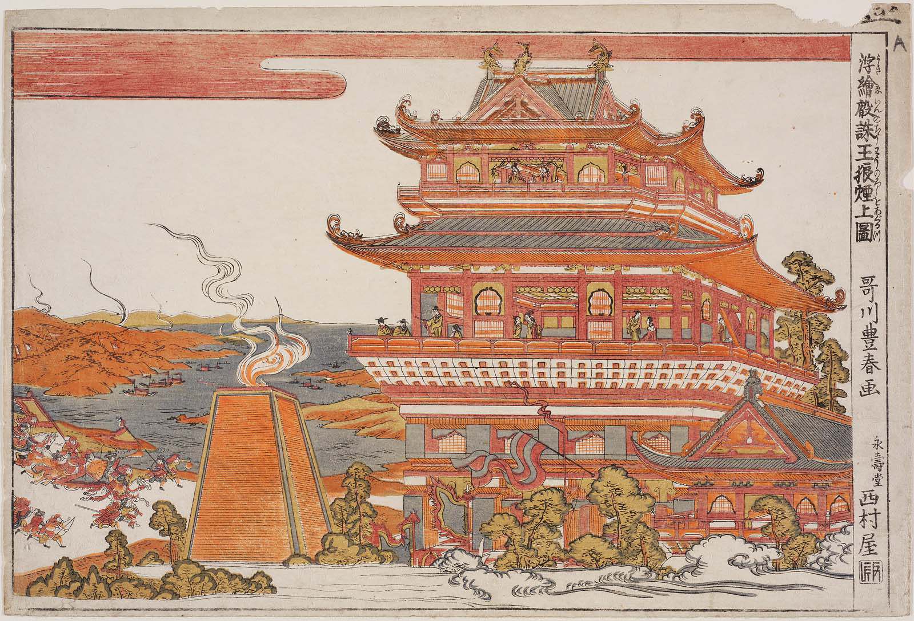
In Computing, we will continue to develop our computing knowledge.
In English, we will be reading How to Train your Dragon, and writing poetry, a diary entry and newspaper articles.
In Maths, we will be continuing to develop our skills in division and multiplication and be learning about fractions.
In PSHE, we will be discussing citizenship and in RE we will be looking at different religions.
In DT we will be evaluating dragon eyes and creating our own using clay.
As Historians, we will be studying the Shang Dynasty, making comparisons to our previous learning of the Maya Civilisation.
Year 4
Spring Term 1
Dynastic Dragons
As athletes we will be developing our skills in Tag Rugby
As Scientists, we will be learning about the digestive system of animals and humans. We will also be investigating the different functions of teeth.

