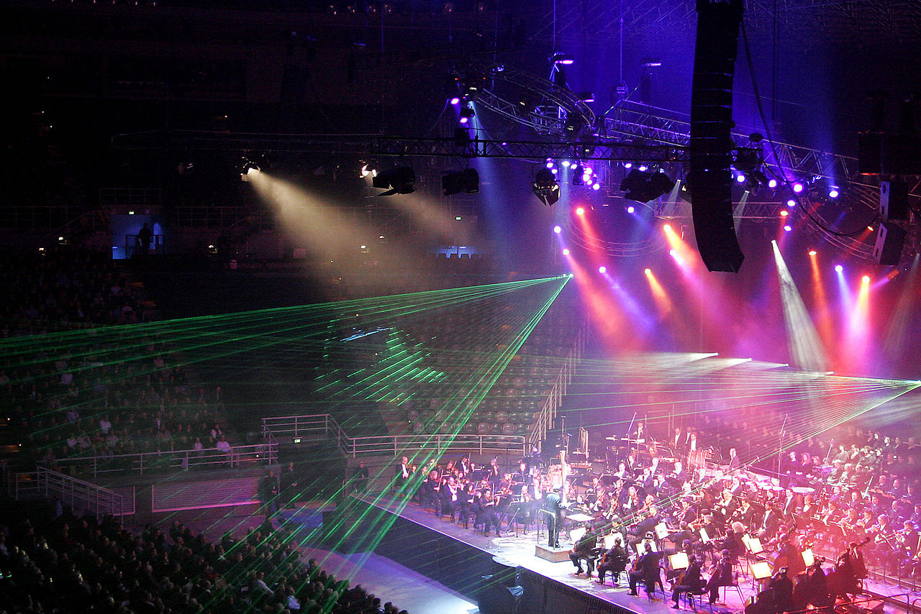
In Computing, we will be creating media using desktop publishing and improving our touch typing.
In Physical Education, we are going to learn how to play Tag Rugby
In French we will be learning about parts of the body as well as the days of the week.

As designers, we will be designing, making and evaluating our own shadow puppets and theatre in order to put on a show.

In English, we are writing blackout poetry and performance poetry. We are writing playscripts to use in our drama lessons. We will also be learning more about instructional writing.
In Religious Education we will be finding out more about why people pray.

As Mathematicians, we will be continuing to learn about multiplication and division. We will also be looking at fractions of shapes and money.
In The Spotlight
Year 3 Spring 1
As Geographers, we will explore economic activity of a region in the UK and a contrasting European region.

As Scientists, we will be studying light, considering reflection and how we see shadows.

