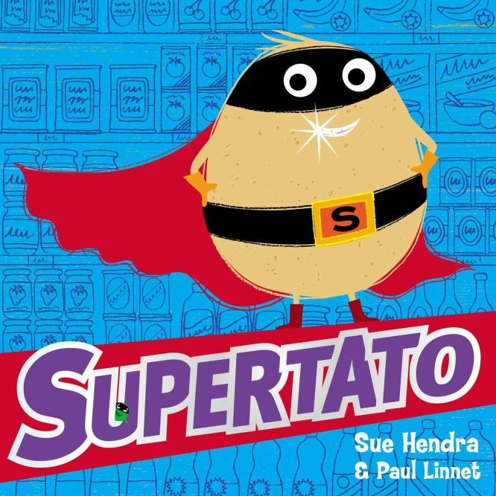
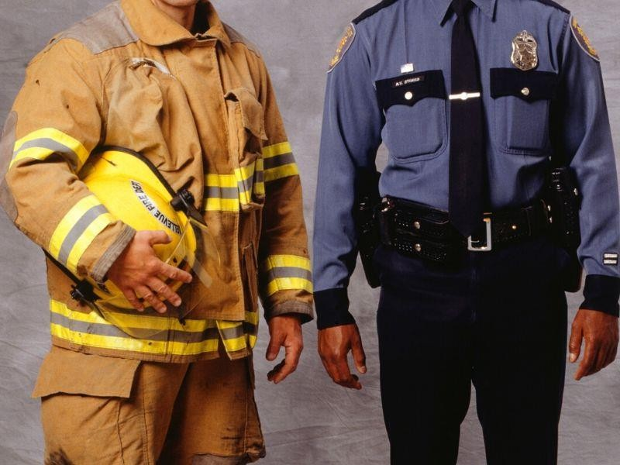
Year 1 Curriculum Newsletter Spring Term 1
As Scientists we will be learning about different materials and exploring different fabrics
Our big question this half term is.......
What is your superpower?

In Art we will be exploring colour, mixing colours and learning about primary and secondary colours. We will use the colours to paint a variety of pictures. This will include a superhero cape and a rainbow which will be the background for our poem using similes.

In PE we will be focusing on gymnastics, learning to balance and improve flexibility.

In our Computing lessons we will be learning how to design and create a rocket on the computer. We will then build and evaluate our finished rocket.
In History we will be looking at our past and how childhood has changed over the years. We will also be finding out how we will be making History and creating a time capsule.
As Mathematicians we will be learning about fractions and money and how to compare different amounts. As well as recapping how to solve addition and subtraction number sentences.
In our PSHE lessons we will be discussing routines and strategies that promote a healthy life and wellbeing.
In English we will be writing our own Superhero story. We will also be looking at poems containing similes.
We will be using out comprehension weeks to predict, decode and read Supertato and fact files about real life heroes such as the police, doctors and firefighters.

