Thorpedene Primary School and Nursery

Booklets for parents and carers to support the learning of Times Tables

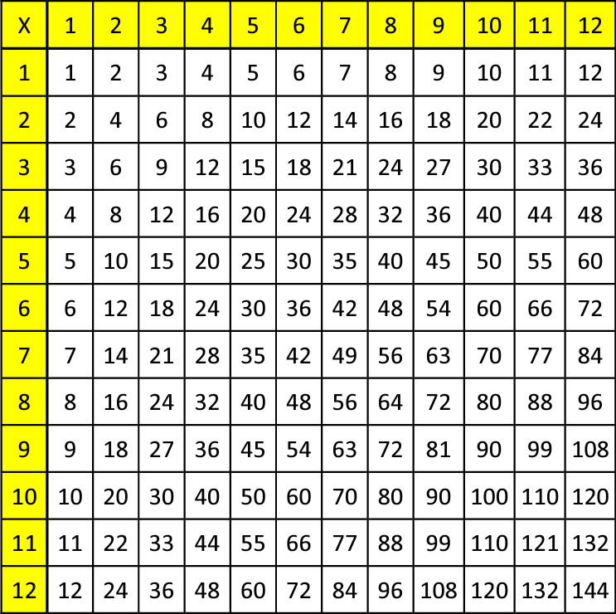

Times Tables guidelines:
The expectation of the National Curriculum is that all children will know their times tables and relative division facts up to 12 x 12 by the end of year 4, when they take the MTC.

For example:
4 x 8 = 32
8 x 4 = 32
32 ÷ 8 = 4
32 ÷ 4 = 8

EYFS: Count in multiples of 2, 5 and 10
Year 1: Count in multiples of 2, 5 and 10. Recall and use doubles to 10
Year 2: 2, 5 and 10 times tables to be learnt
Year 3: 3, 4 and 8 times tables to be learnt
Year 4: All times tables 12 x 12 to be learnt
Year 5: All times tables 12 x 12 have been learnt and working towards instant recall, including division facts
Year 6: Thorough knowledge of all tables expected with instant recall

Handy tips for helping your child learn their Times Tables:

- Learn a little at a time.
- Try different strategies-all children learn in different ways: some through games, through pictures, through songs.
- Constant revision is important-little and often will help your child learn these times tables facts.
- Demonstrate using real life objects eg “Look there are three lots of four rows of buttons/counters/ baked beans.”
- Use real life situations to develop understanding further. For example, “If you save 3p each day, how much would you have on day 7?”
- Use TTRockstars to help. Use the garage section so that the game adapts to support your child’s learning pattern. Please see your class teacher for the log in.
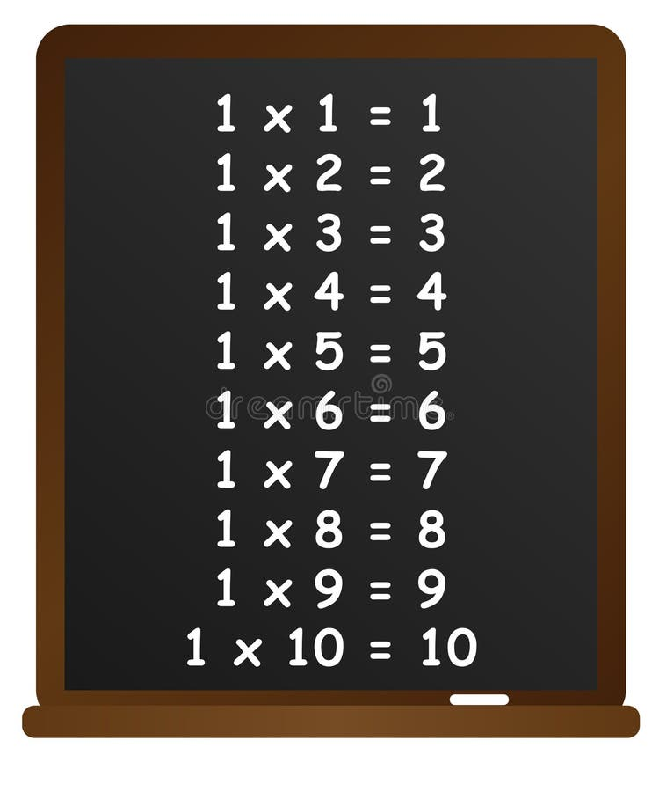

Useful websites to support learning:

Times Tables Rock Stars: Play

Multiplication Tables Check - Mathsframe

Times tables games - Learn them all here!

Online Times Tables Tests - TimesTables.me.uk

Times tables games - Timestables.co.uk

Multiplication Tables Check - 2025 - Timestables.co.uk

Times Tables

Learning resources about times tables - BBC Teach

Times Tables Games for 7 to 11 year olds



