
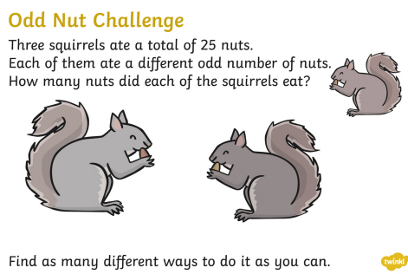
Design a Tally Chart for your family’s favourite rainforest animals.

Design a Bar Chart for your family’s favourite rainforest animals.

Make a list of all the different countries in South America. Put them into a table to show what currency they use, their population and the size of the country in square kilometres. You can add any other facts you like.
Find out about an animal that lives in the rainforest and make a model or create a piece of art that shows it in its environment.
A selection of complimentary side orders may also be offered throughout the term for you to take home with you.
Write 10 facts about Brazil or any of the other countries in South America

Write a postcard home to your family from the rainforest.
Write a poem about the creatures and plant from the rainforest, using your senses.

Write a letter of complaint to the prime Minister about deforestation.
Write a non-chronological report about a rainforest animal- gorilla, anaconda, toucan, lemur or a tree frog.

Write a scientific account about the different layers of the rainforest, The understory, emergent layer, canopy layer and forest floor.
Imagine you are a rainforest guide and write a story about making a journey through the rainforest.

Year 4
TAKEAWAY HOMEWORK MENU
Choose your homework each week from the menu below.
The Peri-ometer indicates the level of challenge in the homework.
You must attempt at least one Extra Hot task every half term.

